Week 15

**Question 1:**

**Given an array of integers, reverse the given array in place using an index and loop rather than a built-in function.**

**Example**

***arr = [1, 3, 2, 4, 5]***

**Return the array *[5, 4, 2, 3, 1]* which is the reverse of the input array.**

**Function Description**

**Complete the function *reverseArray* in the editor below.**

***reverseArray* has the following parameter(s):**

***int arr[n]*:  an array of integers**

**Return: *int[n]*: the array in reverse order**

**Input Format:**

**The first line contains an integer, *n*, the number of elements in *arr*.**

**Each line *i* of the *n* subsequent lines (where *0 ≤ i < n*) contains an integer, *arr[i]*.**

**Program:**

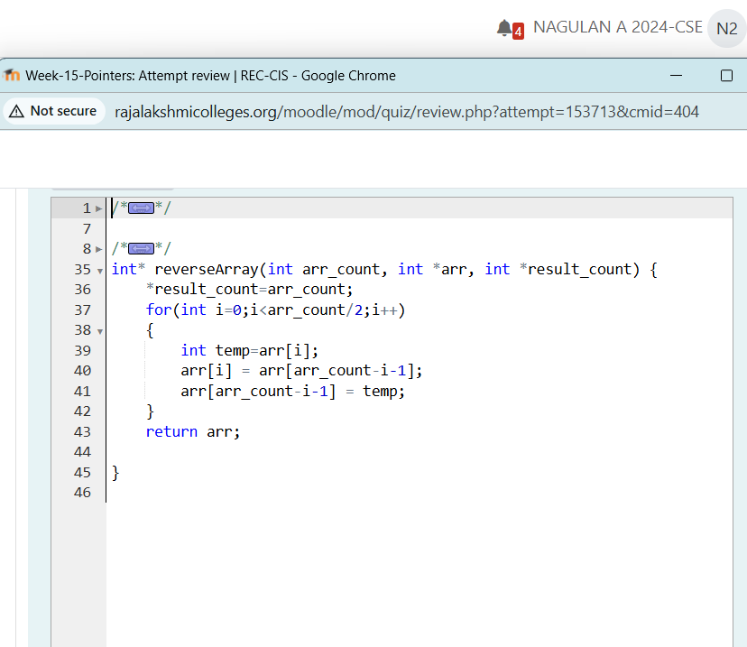

**Output:**

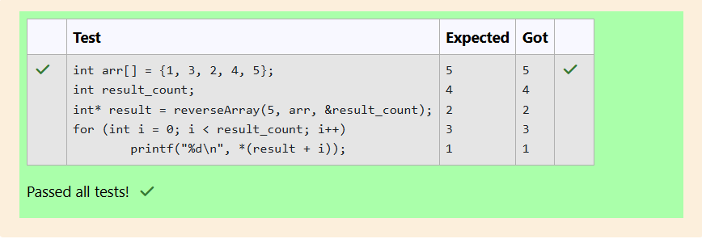

**Question 2:**

**An automated cutting machine is used to cut rods into segments. The cutting machine can only hold a rod of *minLength* or more, and it can only make one cut at a time.**

**Given the array *lengths[]* representing the desired lengths of each segment, determine if it is possible to make the necessary cuts using this machine. The rod is marked into lengths already, in the order given.**

**Input Format:**

**The first line contains an integer, *n*, the number of elements in *lengths*.**

**Each line *i* of the *n* subsequent lines (where *0 ≤ i < n*) contains an integer, *lengths[i]*. T**

**he next line contains an integer, *minLength*, the minimum length accepted by the machine.**

**Program:**

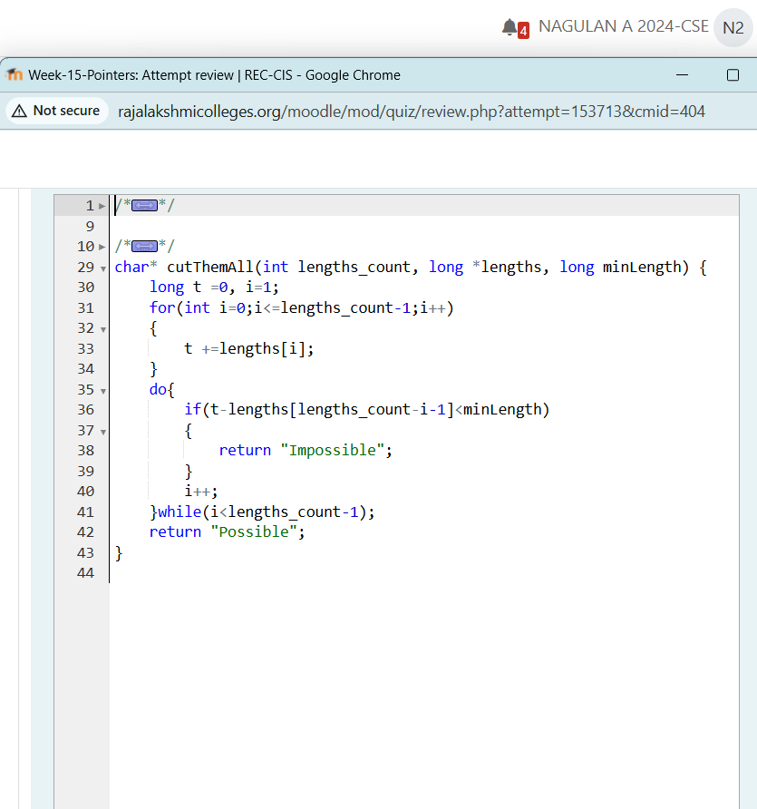

**Output:**

